Windsock Village Property Owner Corporation Meeting
Tuesday, October 18, 2022 @ 6:30 PM teleconference

Meeting called to order at 6:32 pm

I. Attendance
Carl Tyler Ann Cady Frank Sullivan
Tom Huckman Greg Howard Mary Power (telephone)
Chris McNevich Chip Johnson Kevin Roll

II. Approve minutes of September 20, 2022 minutes
Approval of Minutes was tabled until next meeting due to technical difficulties.

III. Treasurer’s Report
Motion made by Carl Tyler and seconded by Tom Huckman to accept Treasurer’s Report as presented.

Money Market Account $87,578.31
Checking Account $75,164.21
Balance Paving Loan $32,162.82
Total O/S Dues $15,100.25

IV. Old Business
- Delinquent Accounts. There are 14 outstanding accounts, from current year assessments and 3 outstanding accounts that include a balance from 2021 plus current year assessments. The three are Prudhommes; Zervas; and Jeffrey Brown. We were awarded a judgement in small claims court against the Prudhommes and they need to pay not later than November 5. We petitioned the Court for periodic payments by the Browns. There is no change from last month in regards to the Zervas. There are liens on the Prudhomme’s, Brown’s, and Zervas’ properties.

- C&R Violations.
    - 24 Old Mill Rd still has unregistered vehicle.
    - 18 Old Mill Rd had an unregistered vehicle sitting on the roadside within the right-of-way. It has been registered, moved out of the right-of-way and resolved.
    - 35 Old Mill Rd (on corner of Navajo Trail) had possible unregistered vehicle. Status of vehicle has been resolved.

V. New Business.
A. The Board received a letter from member, Paula Moore, dated October 3rd, resigning her from her position as treasurer effective immediately. Motion was made by Carl Tyler and seconded by Mary Power nominating Kevin Roll to complete the remainder of Paula Moore’s term. Motion Passed.
B. Jen Huckman, who is interested in taking the bookkeeping position, submitted a resume. Kevin Roll made a motion to offer position to Jen paying the same rate paid previous bookkeeper of $25/hour. Motion was seconded by Mary Power and passed.
C. Mary Power volunteered to e Treasurer as a tryout during the next few months.
D. Plowing Contract: Dave Cribbe from GW Brooks, our plowing contractor, reached out regarding our plowing contract. We need to modify the three-year contract. There are changes needed to be made in the language of the existing contract, specifically Article 4 for defining current versus projected costs. We are in year 2 of 3 year. Aviation is also in contact with GW Brooks and Greg Howard indicated that he would be in touch with Aviation to coordinate. A special meeting may need to be called to review and approve the new contract.

A motion was made to adjourn by Kevin Roll and seconded by Tom Huckman, to adjourn.
Motion passed. Time 7:33 pm. Next meeting November 20, at 6:30 PM.

Respectfully submitted,

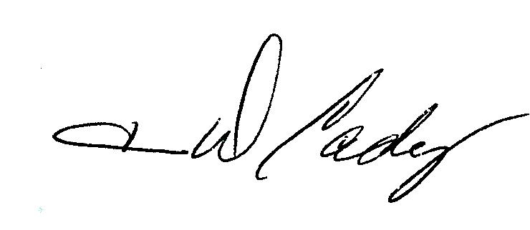
Ann Cady, Secretary

