Windsock Village Property Owner Corporation Meeting
Tuesday, December 20, 2022 @ 6:30 PM 6 Apache, West Ossipee, NH

Meeting called to order at 6:37 pm

I. Attendance
Carl Tyler Ann Cady Frank Sullivan
Tom Huckman Greg Howard Mary Power (telephone)
Chris McNevich (phone) Kevin Roll

II. Approve minutes of October 20, 2022 and November 9, 2022 meetings
Motion was made by Tom Huckman and seconded by Mary Powers to accept the minutes of the regular meeting October 20, 2022 as written. Motion passed. Motion made of Kevin Roll and seconded by Tom Huckman to accept the minutes of the November 9, 2022 special meeting as written. Motion passed.

III. Treasurer’s Report
Motion made by Kevin Roll and seconded by Carl Tyler to accept Treasurer’s Report as presented.

Money Market Account $87,579.77
Checking Account $71,970.12
Balance Paving Loan $27,967.94
Total O/S Dues $ 7,970.98

IV. Old Business
- Delinquent Accounts. We are awaiting the court’s ruling on our motion requesting periodic payments be made by the Prudhommes. Jeffrey Brown has paid his account. . The remaining liens are on the Prudhomme’s, and Zervas’ properties. A notice intent to file small claim suits against delinquent accounts will be sent out in February 2023.

- C&R Violations.
24 Old Mill Rd has registered his formerly unregistered vehicle.

V. New Business.
A. There was general discussion of plowing procedures during the winter.
.
A motion was made to adjourn by Tom Huckman and seconded by Kevin Roll, to adjourn.
Motion passed. Time 6:56 pm. Next meeting February 14, at 6:30 PM via teleconference.

Respectfully submitted,

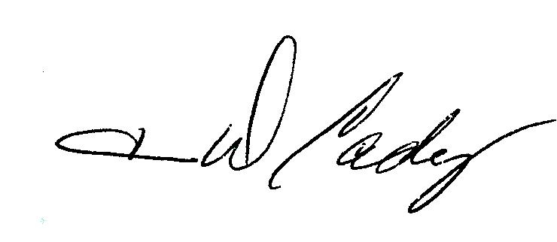
Ann Cady, Secretary

