Windsock Village Property Owners Corporation Meeting
Tuesday October 19, 2021 @ 6:30 pm
4 Apache Lane
Meeting called to order at 6:33 pm
- Attendance
Ann Cady Paula Moore
Carl Tyler Tom Huckman
Christopher McNevich Chip Johnson
Greg Howard

- Approve minutes of October 19, 2021 meeting
Motion to accept minutes as written. Motion passed.

- Treasurers Report
Motion to accept report as presented. Motion passed.

Money Market Account $75,571.64
Checking Account $53,823.16
Balance on RE Loan $52,417.91
Total O/S Dues $10,307.26

- Old Business
- Delinquent Accounts
- The number of delinquent accounts is 16. Letters will be sent to delinquent owners in January 2022 with their account statement. There was discussion of imposing an interest charge on unpaid balances and whether owners should be notified they need to pay in full or be subject to small claims court filing and interest. It was decided to maintain status quo until annual meeting.
- Small claims court case brought by Frank Sullivan has been delay until July 2022.
- C&R Violations. Status quo.
- 11 Skyhawk fence not repaired. Certified letter sent.
- Curtis DeWitt of 24 Old Mill Rd issue continues with attorney.
- 31 Navajo Trail the previously unregistered vehicle is currently not on the property but construction on second building continues.
- Road Maintenance.
- Crack sealing completed and went well. The work was done well and the final price was good.
- The roads were cleared of pine needles as were the catch basins. Shoulder work including cutting saplings and brush was completed.
- Brooks came in and marked drains and electric connections in preparation for snow plowing.
- New Business
- There was discussion regarding the building newly constructed by Neil Underwood on Navajo Rd as to whether it was within the boundaries approved by the Corporation. Measurements were taken and it was found to be in compliance.

Motion to adjourn passed. Adjourned at 7:06 PM Next meeting on February 15, 2022 at 6:30 pm via zoom.
Respectfully submitted,
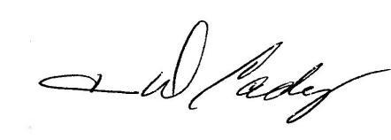
Ann D. Cady, Secretary

