Windsock Village Property Owner Corporation Meeting
Tuesday, February 14, 2023 @6 :30 PM teleconference

Meeting was called to order at 6:34 pm

- Attendance
Kevin Roll Ann Cady Tom Huckman
Frank Sullivan Mary Power Chris McNevich
Carl Tyler Greg Howard Chip Johnson

- Approve minutes of December 20, 2022 meeting. It was moved by Carl Tyler and seconded by Mary Power to approve the minutes as amended. Motion passed.

- Treasurer’s report Motion was made by Frank Sullivan and seconded by Tom Huckman to accept the report as presented. Motion passed.

Money Market Account $87,579.77
Checking Account $47,341.96
Balance Paving Loan $25,854.40
Dues Credit Balance $ 375.73
Total Outstanding Dues $ 6,850.17

- Old Business
- Delinquent Accounts. There are eight accounts outstanding, seven of which are of concern. At letter was sent with statements at the end of January giving delinquent accounts until February 15, 2023 to either pay or set up a plan to pay. Failure to do either will result in the filing of a small claims court case.

- C&R Violations. There are no new violations noted. Everyone in compliance.

- New Business
- Snowmobile Access Motion. Kevin Roll made a motion to request our snow plowing company to cut an opening in the berm where the taxiway intersects Old Mill Rd to ease the crossing of snow mobiles. There was discussion and Tom Huckman offered to cut the opening himself since he has the equipment. He also agreed to do so yearly.
- Budget. The budget for next year needs to be considered at our next meeting.

- Public Comment None
Next meeting March 21, 2023 via Zoom
Motion made by Tom Huckman and seconded by Mary Power to adjourn. Motion passed. Meeting adjourned at 6:53pm

Respectfully submitted,
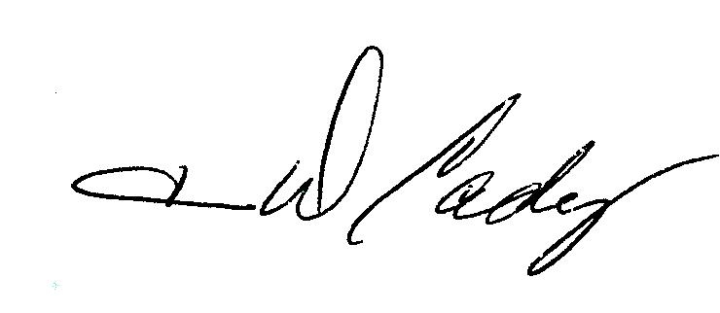 Ann Cady

