Windsock Village Property Owner Corporation Meeting
Tuesday, March 21, 2023 @6 :30 PM teleconference

Meeting was called to order at 6:33 pm

- Attendance
Kevin Roll Ann Cady Tom Huckman
Frank Sullivan Mary Power Chris McNevich
Carl Tyler Greg Howard Chip Johnson

- Approve minutes of February 21, 2023 meeting. It was moved by Tom Huckman and seconded by Mary Power to approve the minutes as written. Motion passed.

- Treasurer’s report Motion was made by Tom Huckman and seconded by Chris McNevich to accept report as presented. Motion passed.

Money Market Account $ 87,579.77
Checking Account $ 44,341.96.
Balance Paving Loan $ 2,854.40
Dues Credit Balance $ 375.73
Total Outstanding Dues $ 6850.17

- Old Business
- Delinquent Accounts. There are five accounts outstanding to be submitted to small claims court.

- C&R Violations. There are no violations noted. Everyone in compliance.

- New Business
- 2023-24 Budget. Tracking across the current budget fixed expenses are down with the exception of road maintenance which is $5654.00 over budget and expenditures may not be done yet. Other line items are on track and there should be some funds available for savings and leveling across the budget. As part of road maintenance, Tom Huckman indicated that Coleman has been contacted regarding road sweeping.

- Plowing Contract Discussion. There was concern expressed by a board member as to whether we had over paid for unnecessary work by the plowing contractor. Greg Howard stated that he had communicated with the contractor regarding the frequency of sanding and was told the decision was made by Scott Brooks. The board decided to consider whether there might be another contractor that offers comparable service and reliability.

Next meeting April 18, 2023 via Zoom. .Motion made by Carl Tyler and seconded by Mary Power to adjourn. Motion passed. Meeting adjourned at 7:25 pm
Respectfully submitted,
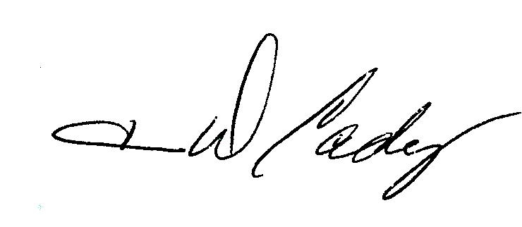 Ann Cady

