Windsock Village Property Owner Corporation Meeting
Tuesday, April 18, 2023 @6:30 PM teleconference (Draft)

Meeting was called to order at 6:31 pm

- Attendance
Kevin Roll Ann Cady Tom Huckman
Frank Sullivan Mary Power Chris McNevich
Carl Tyler Greg Howard Chip Johnson

- Approve minutes of February 14th meeting. It was moved by Carl Tyler and seconded by Mary Power to approve the minutes as corrected. Motion passed.

- Treasurer’s report Motion was made by Carl Tyler and seconded by Chip Johnson to accept report as presented. Motion passed.

Money Market Account $ 87,584.05
Checking Account $ 26,114.37 $25,156.87 reflects uncleared transactions
Balance Paving Loan $ 21,575.16 as of 03-17-23 statement maturity 10-01-24
Dues Credit Balance $ 375.73
Total Outstanding Dues $ 5,586.35

- Old Business
- Delinquent Accounts. Trust for 16 Navajo Trail paid all but small amount on dues. There are still three claims in small claims court and periodic payments request has been filed on the Prudhomme property. Remaining properties with unpaid balances still unpaid by the time of the annual meeting will have small claims suits filed.

- C&R Violations. There was a complaint received regarding 8 Navajo Trail not having completed construction within a year. The one-year rule does not apply as there has been no construction started, only the removal of trees. The owner of 31 Navajo Trail needs to be contacted regarding current status of construction project. Board member will reach out to owner.

C. 2023-2024 Budget. Current budget indicates that the winter maintenance line item is over budget.by about $8200. There was discussion about moving funds between line items for current budget and increasing the winter maintenance for next year. The paving loan will be retired in the fall which gives extra funds for next years budge. Will try to keep dues the same as current year. Vote on the proposed budget will at the next meeting.

V. New Business
- Annual Meeting. Motion was made by Ann Cady and seconded by Chris McNevitch to hold the annual meeting at 1 pm, June 10^{th,} 25 Navajo Trail, in the hangar of Mary Power and Tim Andrew. Motion passed. Windsock Aviation will hold their meeting in the morning, same location. Lunch will be in between the meetings. Carl Tyler will assist with the save the date cards which need to be sent 30 days before the meeting. Meeting packet will be sent 2 weeks before meeting.

VI. Public Comment
A. There was some discussion on tree and limb clearing by the utilities company. Wood that has been left is available to the community but takers should check with owner before removing. Remaining wood will be picked up as part of winter clean-up.

B. It was decided that the spring community clean up would be held May 13, 9 am, meeting at gazebo. Trash bags will be provided.

Motion to adjourn was moved by Tom Huckman and seconded by Mary Power. Motion passed. Adjourned at 7:30 pm. Next meeting will be May 16th, 6:30 pm.

Respectfully submitted,
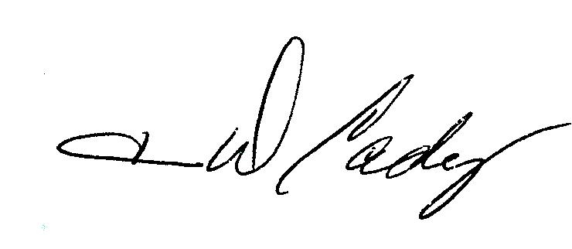
Ann D Cady, Secretary

